EXPERIMENT – 3

NAME: SHERIN KATHERINA D ROLL NO: 240701495

- COMMAND LINE INTERFACE

import sys
def add_numbers(a, b):
return a + b

if __name__ == "__main__":
if len(sys.argv) != 3:
print("Usage: python add_cli.py <num1> <num2>")
else:
try:
num1 = float(sys.argv[1])
num2 = float(sys.argv[2])
result = add_numbers(num1, num2)
print(f"Result: {result}")
except ValueError:
print("Please enter valid numbers.")

OUTPUT :-

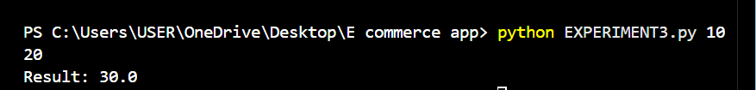

- GRAPHICAL USER INTERFACE

import tkinter as tk
from tkinter import messagebox
def calculate_sum():
try:
a = float(entry1.get())
b = float(entry2.get())
result = a + b
messagebox.showinfo("Result", f"Sum = {result}")
except ValueError:
messagebox.showerror("Error", "Enter valid numbers")

root = tk.Tk()
root.title("Simple Calculator")
root.geometry("300x200")
root.resizable(False, False)

tk.Label(root, text="First Number").pack(pady=5)
entry1 = tk.Entry(root)
entry1.pack()

tk.Label(root, text="Second Number").pack(pady=5)
entry2 = tk.Entry(root)
entry2.pack()

tk.Button(
root,
text="Add",
bg="green",
fg="white",
command=calculate_sum
).pack(pady=15)

root.mainloop()

OUTPUT:-

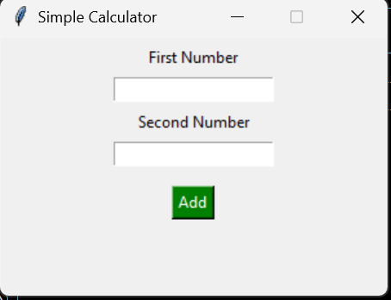
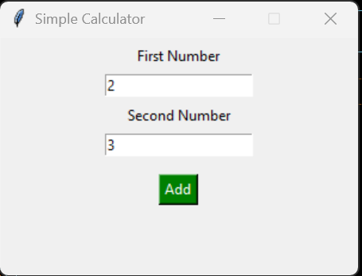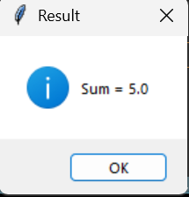
- VOICE USER INTERFACE

import speech_recognition as sr
def voice_addition():
print("Voice User Interface (Simulated)")
command = input("Say two numbers (example: 10 20): ")

try:
a, b = map(float, command.split())
print("Result:", a + b)
except ValueError:
print("Invalid input")

if __name__ == "__main__":
voice_addition()

OUTPUT:-

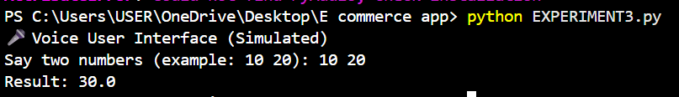
- USER SATISFACTION COMPARISON

def survey():
print("Rate your satisfaction (1–5):")

try:
cli = int(input("CLI: "))
gui = int(input("GUI: "))
vui = int(input("VUI: "))

if not (1 <= cli <= 5 and 1 <= gui <= 5 and 1 <= vui <= 5):
print("Ratings must be between 1 and 5.")
return

avg = (cli + gui + vui) / 3

print("\nSatisfaction Ratings:")
print(f"CLI: {cli}")
print(f"GUI: {gui}")
print(f"VUI: {vui}")
print(f"Average Score: {avg:.2f}")

except ValueError:
print("Invalid input!")

if __name__ == "__main__":
survey()

OUTPUT:-

